**How to Access your Whitecaps Email**



1. Navigate to the official GC website: <https://www.gc.edu/>. Once there, click on the “Whitecaps Toolbox” option on the top blue bar of the webpage. If you are utilizing a mobile device, click on the hamburger menu  located on the top right of the page to display the options.

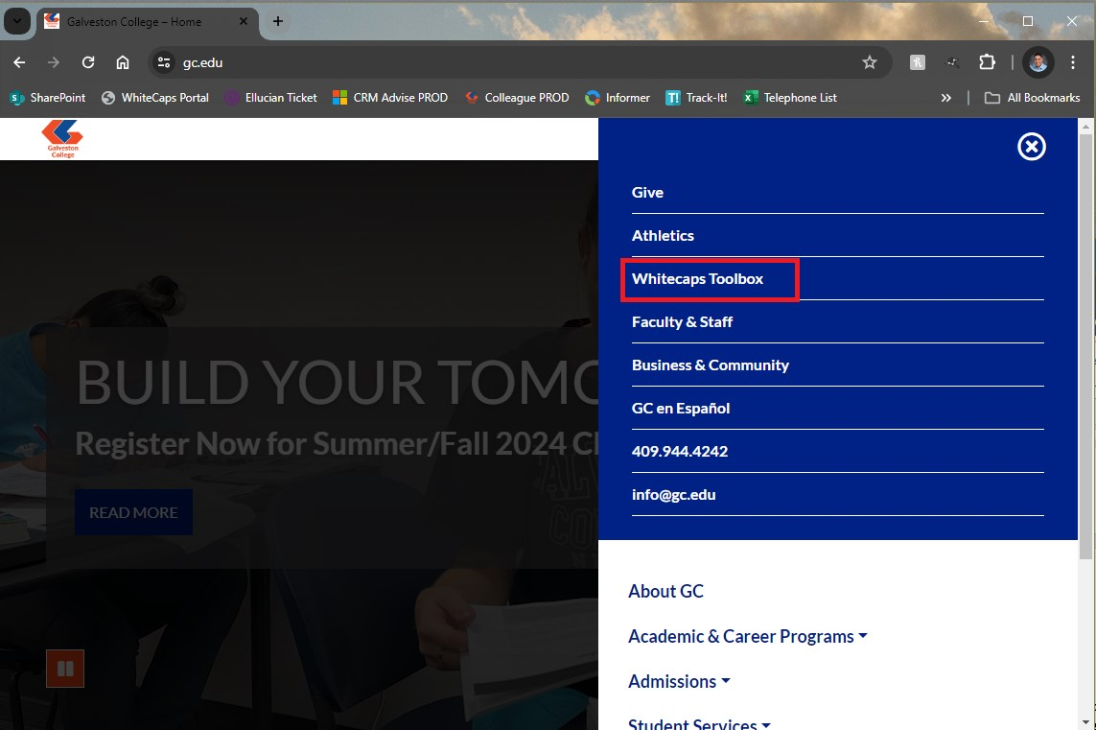

1. Click on the “Outlook Mail” option to access the Microsoft login page.

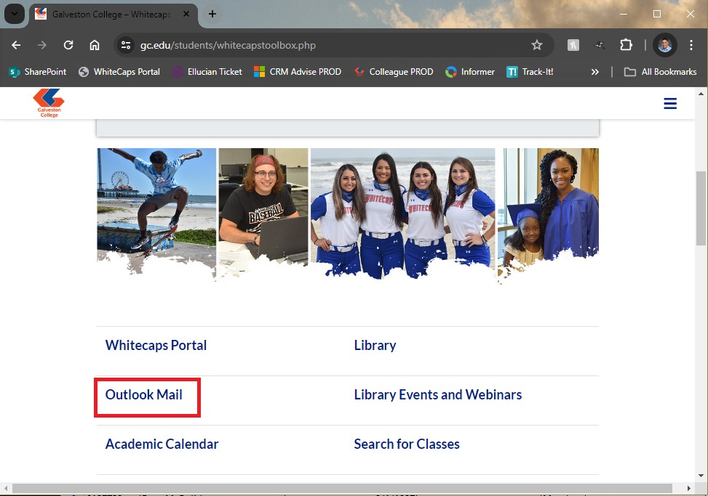

1. A login window for Office 365 will appear. Under “Sign in” please ty pe your Office 365 email address, which should be made up of your first and last name. The next screen will prompt you to put in your password. The third screen will request that you complete your authentication method of choice to gain access.

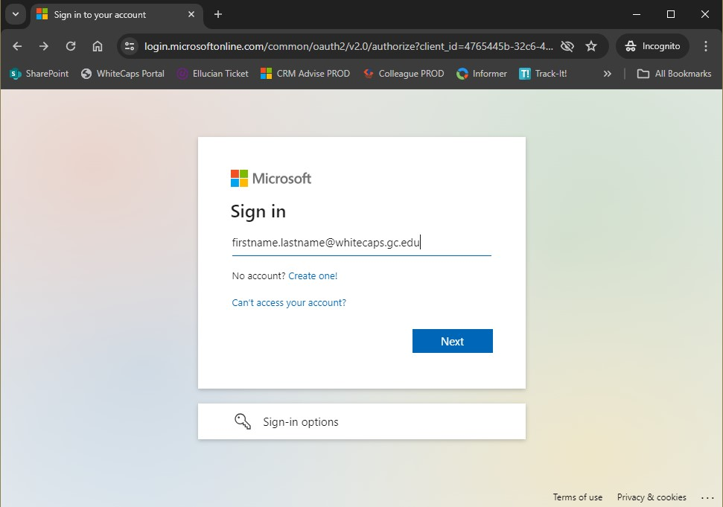

1. From here you should see all of the available apps in Office 365, most notably “Outlook” for email:

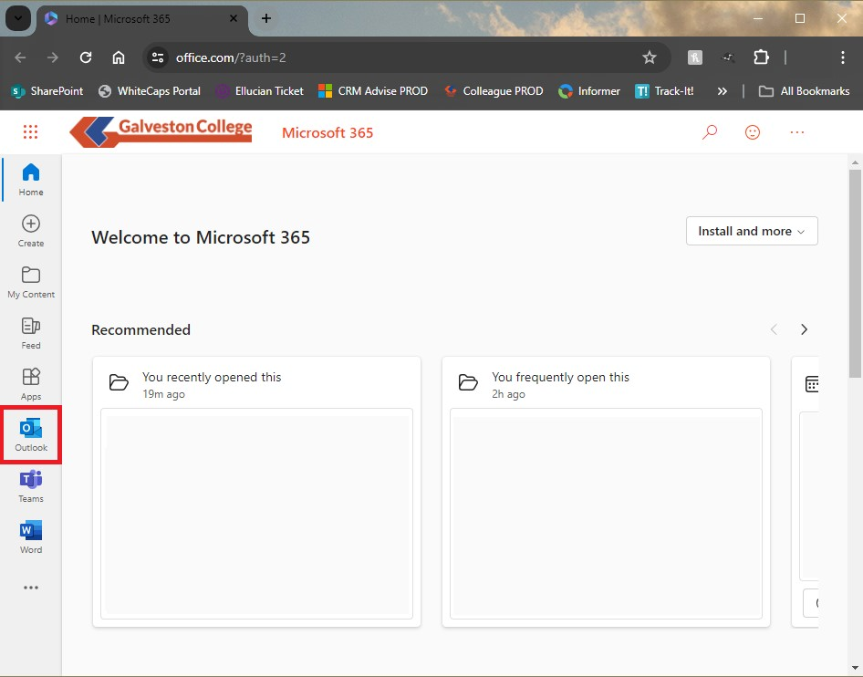

###### If you experience any technical difficulties, please contact the IT Service Desk at 409-944-1352 during normal business hours or via email at [servicedesk@gc.edu](mailto:servicedesk@gc.edu).

###### If it is after hours, we’ll contact you as soon as we’re back in the office!