**XMedius Fax User Guide**



Contents

Creating a fax using XMedius web application 3

Creating a fax using email 8

Creating a fax using Ricoh copier 11

## Creating a fax using XMedius web application

1. Open up your preferred internet browser and navigate to the XMedius SendSecure site using the following URL:

<https://login.xmedius.com/galvestoncollege/sso>

1. You are prompted to log into the site using single sign on (SSO). Confirm that you are logging into the GC instance by checking that the GC logo is displaying at the top of the page and the account “galvestoncollege” is showing for the account. Click on the button to access the XM site.

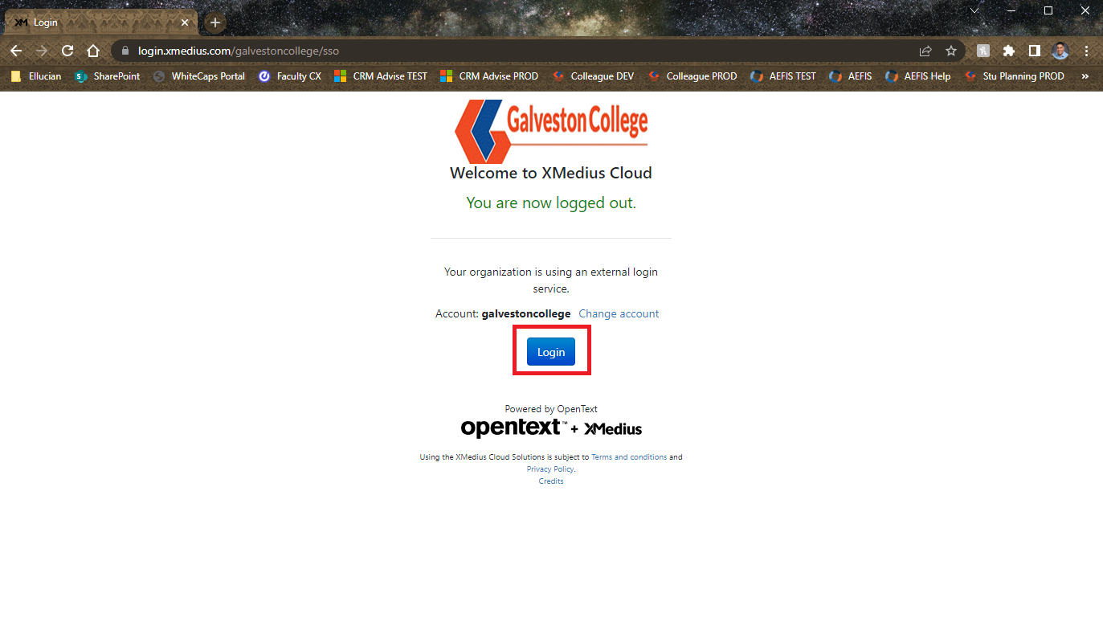

1. After logging in successfully, click on the button on the top left to access the web fax compose page.

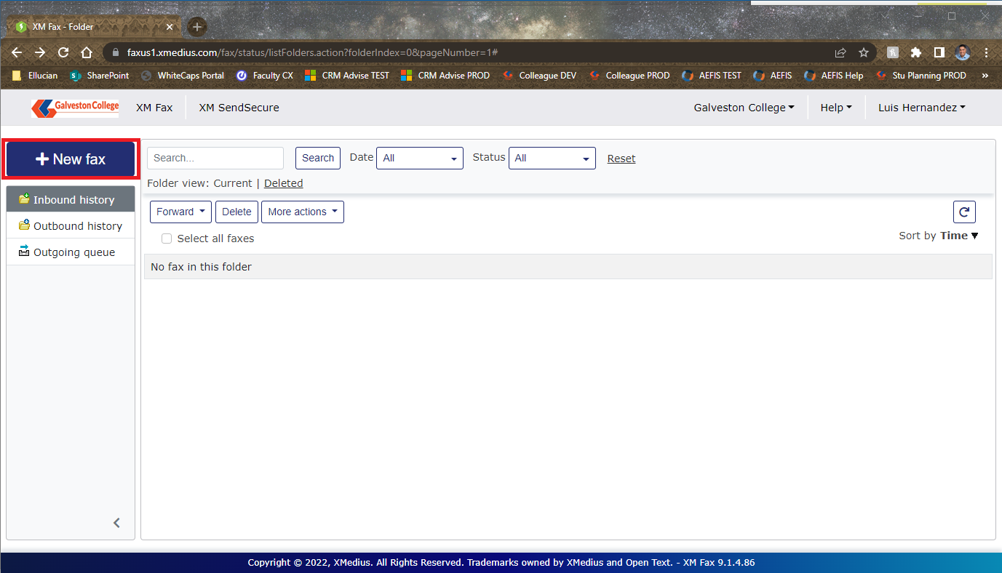

1. Fill out the fields under the Recipients, Cover Sheet, and Attachments sections.

* Recipients
  + Name – Name of the person who will receive the fax.
  + Company – Name of the company the recipient works for.
  + Fax (Required) – Fax number that the attachments will be sent to.
* Cover Sheet
  + Style – The format for the cover sheet of the fax. This can be set to “GC Standard Fax.cse” or use another cover sheet in the list made available to your profile. Contact the Service Desk to submit a request for another cover sheet to be added.
  + Subject – The heading for the fax that will be sent out.
  + Comment – Any additional details that may want to be provided alongside the fax (i.e. Attention To: ).
* Attachments
  + This section is reserved for the documents that will be faxed over. You can drag and drop items in the provided section or click on the button to search for documents on your computer.

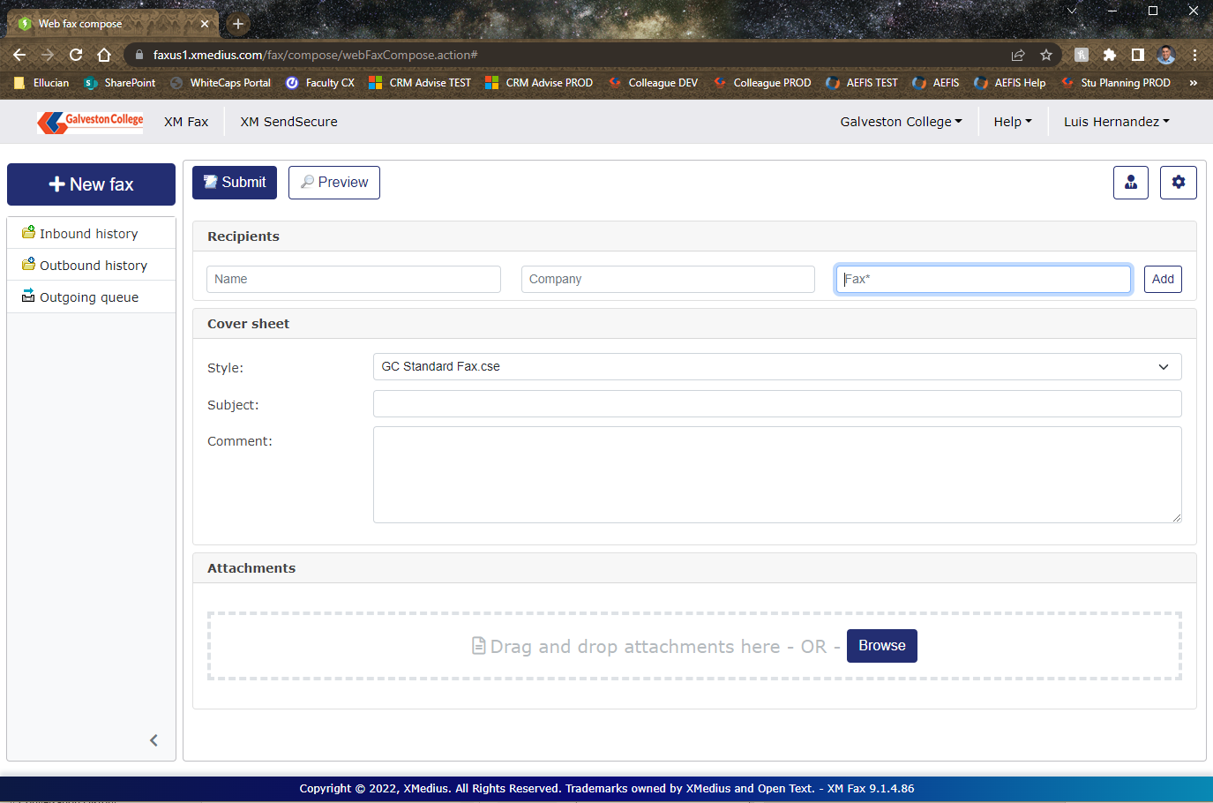

1. Confirm that the fax is filled out correctly and is showing as expected by clicking on the button. Once you have looked over the preview, you can click on the back button to return to the web fax compose page if changes are needed or click on the button to send the fax ~~out~~.

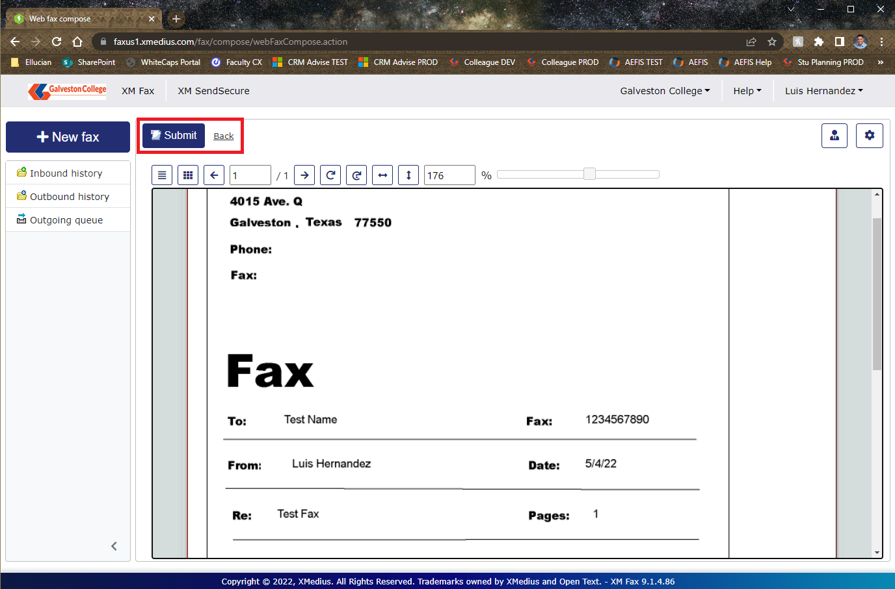

1. The time for the fax to complete the transmission will depend on the number of documents being faxed over. To check on faxes that you have received or sent out, you can check on the Inbound history and Outbound history folders. In the screenshot below, you can see an example that I have cancelled which resulted in a failure:

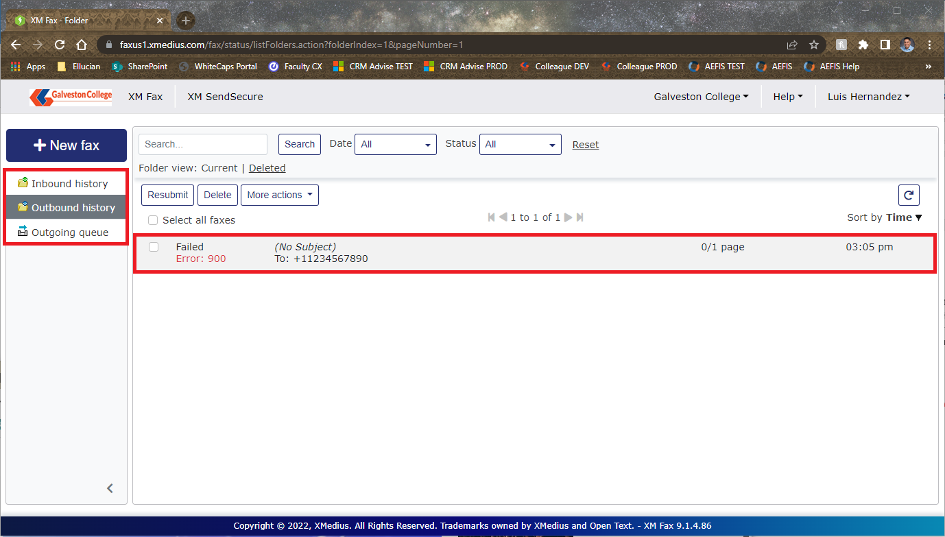

## Creating a fax using email

1. Launch Outlook and click New Email to start to compose a new email message.
2. If needed you may attach documents that need to be included in the fax by dragging and dropping the files or clicking on the attach file button within the Message ribbon of the email as shown below:

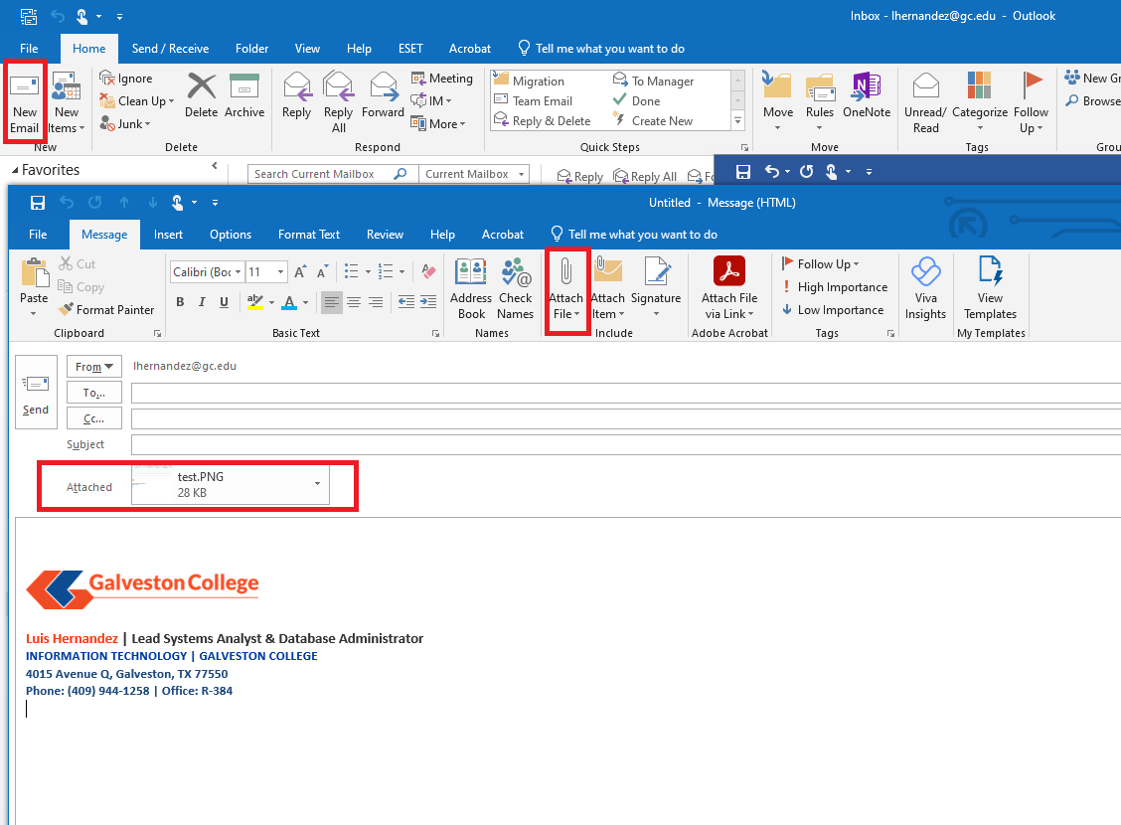

1. Fill out the following fields to submit the email as a fax:

* To: – Input the fax number of the recipient followed by “@xmedius.com”. For example, if the recipient’s fax number is ‘1234567890’, the “To:” field would read [1234567890@xmedius.com](mailto:1234567890@xmedius.com).
* Subject: – Input the heading for the fax that will be sent out.
* Body – Type any additional details that may needed for the fax.

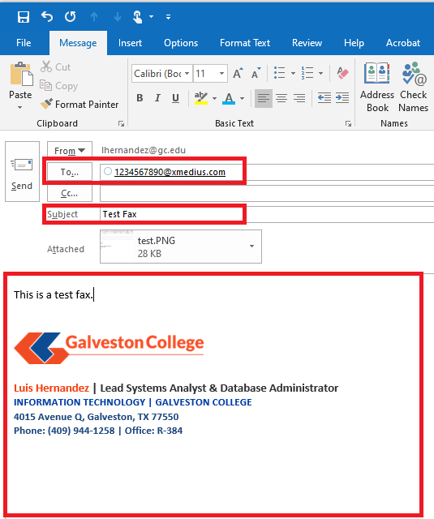

1. Confirm that the fax is filled out correctly and contains the documents you want to fax over as attachments. Click on the send button to send the fax to the recipient. After you click on send, XMedius will attempt to send the fax out via email. When the attempt is completed, an email confirmation will be sent to your inbox informing you that the fax was either successful or has failed. Below is an example of a successful fax being sent out via email:

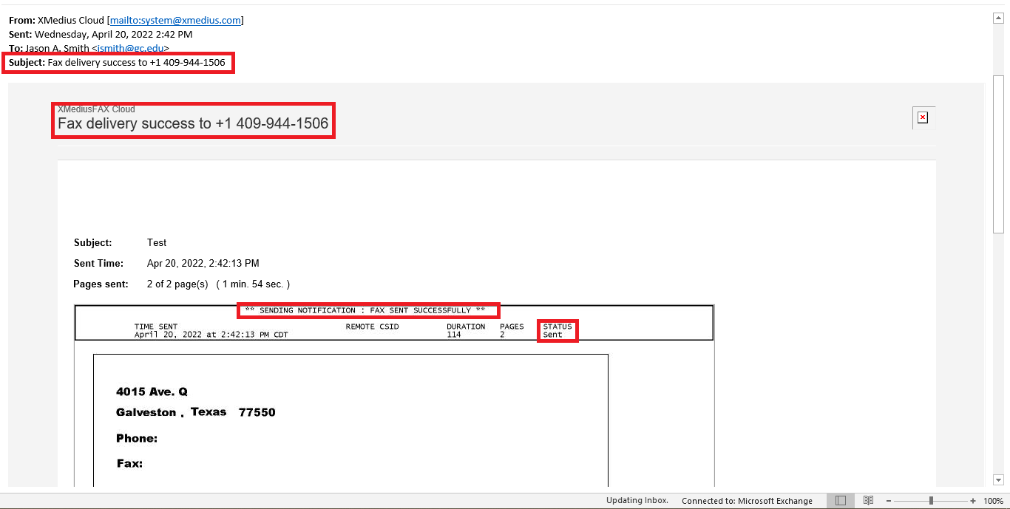

## Creating a fax using Ricoh Copier

1. Go to any Ricoh copier and place the documents you wish to fax in the document feeder. Afterwards, use your HID card to log into the copier. When logged in, you will be at the PaperCut MF main menu screen. Select the Device Functions button to go to the Ricoh main menu screen.

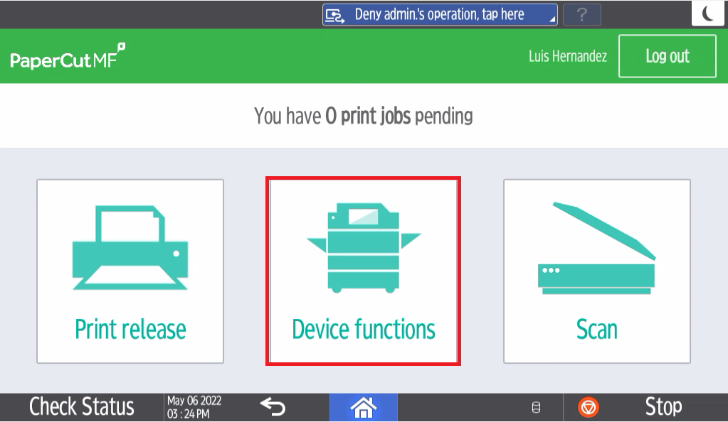

1. Within the Ricoh home screen, select the XMediusFAX button. This will take you to the fax creation screen.

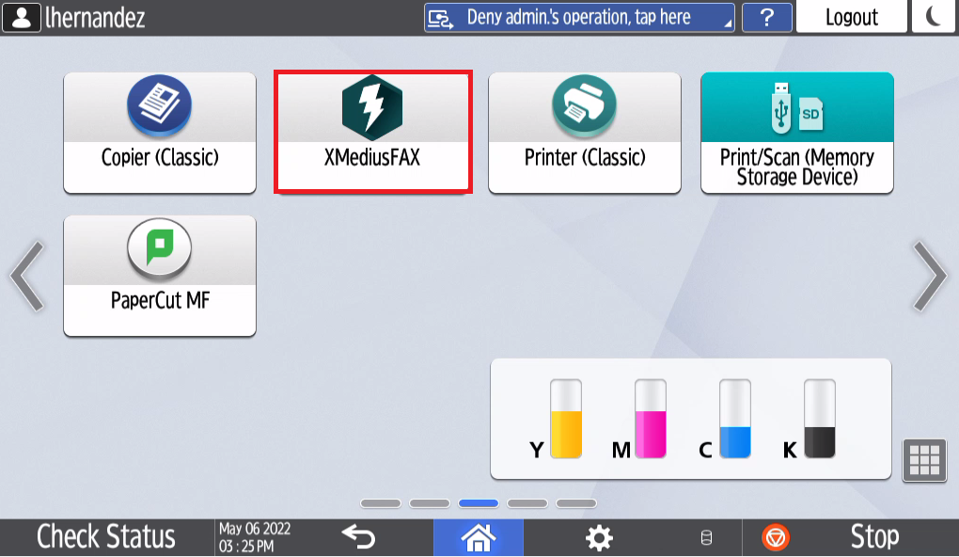

1. Fill out the following information on the screen:
   1. To: Fax number that the attachments will be sent to.
   2. Subject: The heading for the fax that will be sent out.
   3. Comments: Any additional details that you may want to include with the fax (i.e. Attention To: ).

When the information has been filled in, click on the green scan button on the top right.

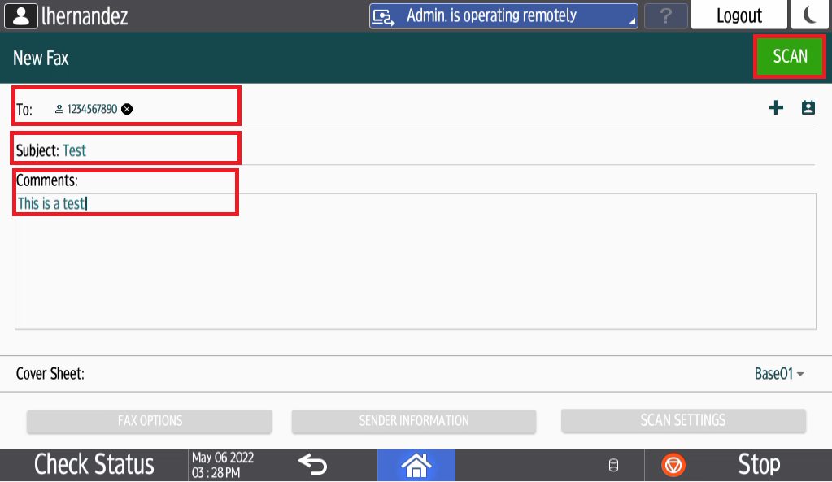

1. The Ricoh copier will begin scanning the documents in the feeder tray. Once the scan is completed, click on the green send button in the middle of the screen to begin transmitting the fax to the delivery service.

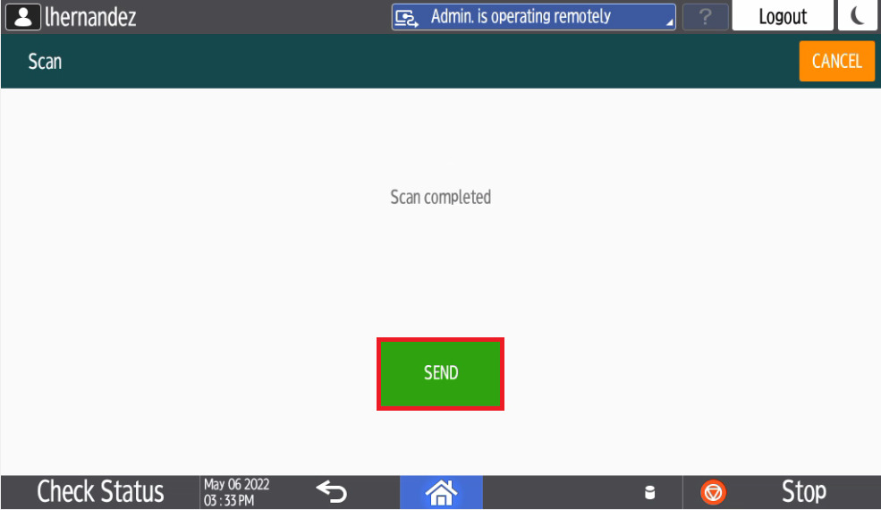

1. After the fax is completed, the screen will inform you that “***Your fax has been successfully sent to the fax delivery service***.” The fax will now be sent over to the intended recipient. Click on the orange “**EXIT”** button on the top right of the touchscreen panel and then the white “**Logout**” button.

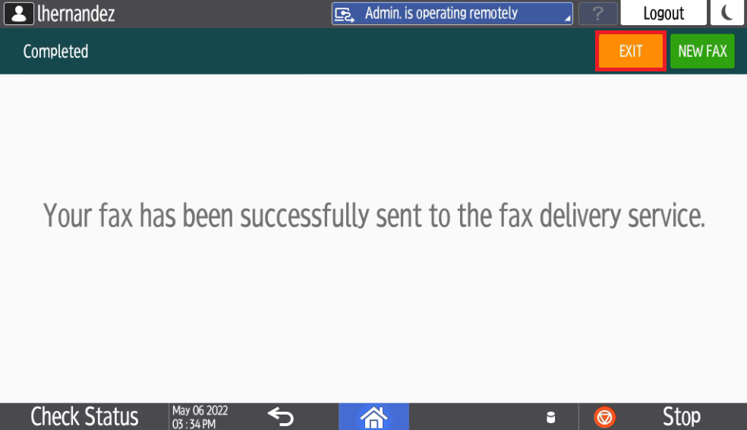

1. After the fax is finished transmitting, an email will be sent to your inbox letting you know if the fax was successful or if it was a failure. The documents that were faxed, along with the cover sheet are included in the attachment. See below an example successful fax:

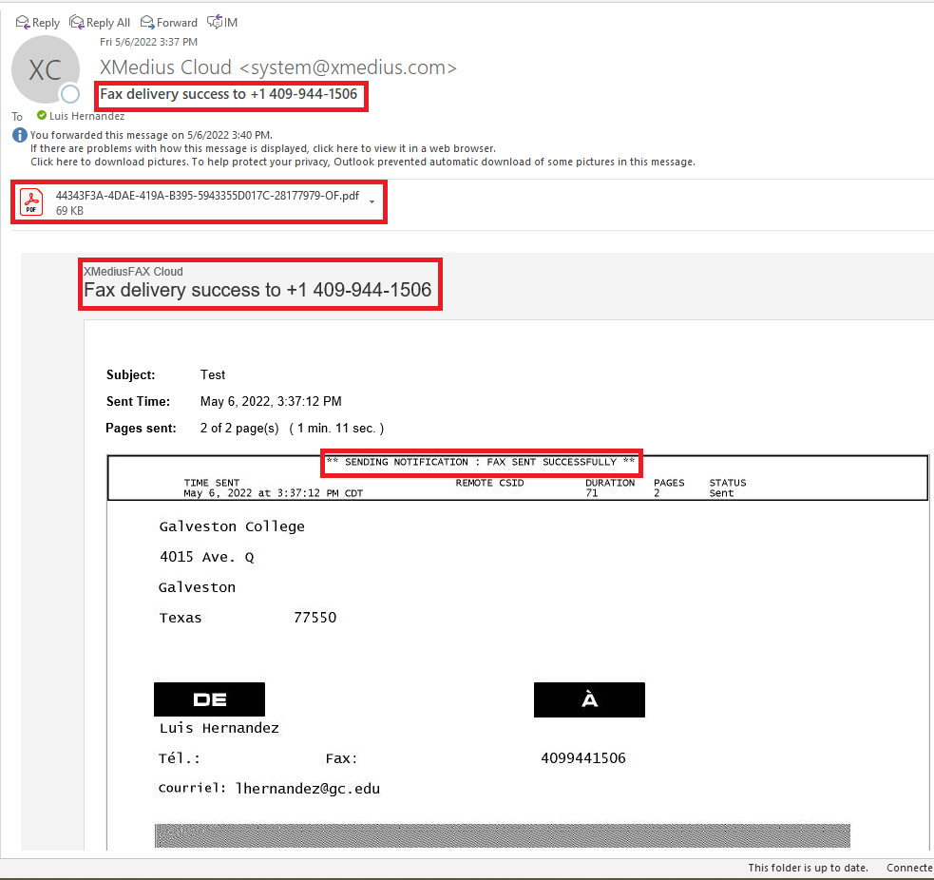  
  
If there are any issues or questions using the Xmedius Fax solution please contact the IT Service Desk at ext. 352 (409-944-1352) or via email at [servicedesk@gc.edu](mailto:servicedesk@gc.edu)!