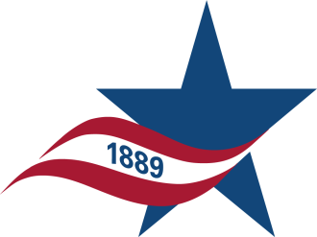 |  | HARRIS COUNTY DEPARTMENT OF EDUCATION  RECORDS MANAGEMENT SERVICES COOPERATIVE  NEW BOX TRANSFER FORM  HCDE WORK ORDER NUMBER ######
CLIENT NAME:  (DISTRICT) | GALVESTON COLLEGE  (4015 Ave. Q, Galveston, TX 77550) |  | DEPARTMENT NAME:  (Dept., Room#, Your Name, email, phone) | Dept. Name  Room#: A-123; your Name, name@gc.edu; Phone#: 409-944-####

HCDE  Barcode | Client Box  No. | Range By:  Year Date-Alpha-Numeric | Contents  Record Name | Destroy  Date
WORK ORDER NUMBER |  | ###### | NUMBER OF BOXES

